CSE 101 ASSIGNMENT - SELEN ERDOGAN

**2- Try led blink demo from the demo programs**

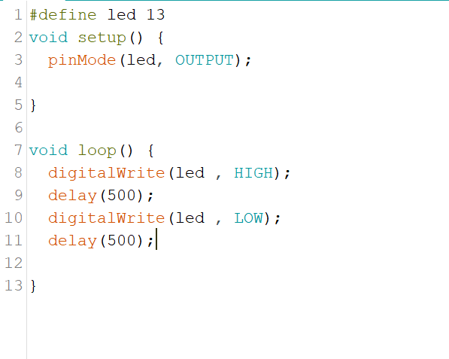

**3- Run blinking led from Basic Examples**

EXAMPLES->BASİCS->BLİNK

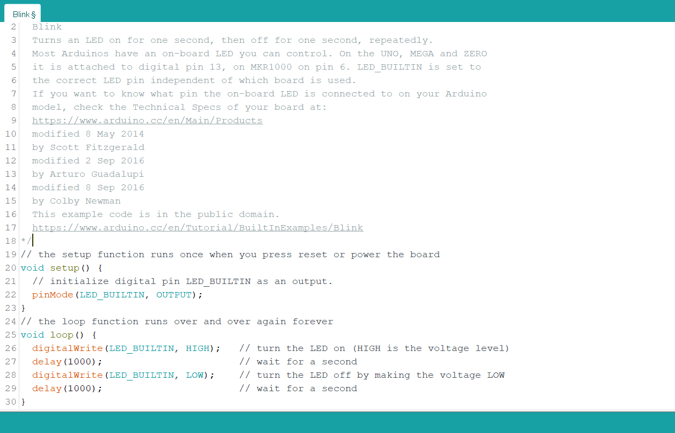

**4- Try Serial ASCII Table example (use serial monitor to see what is happening)**

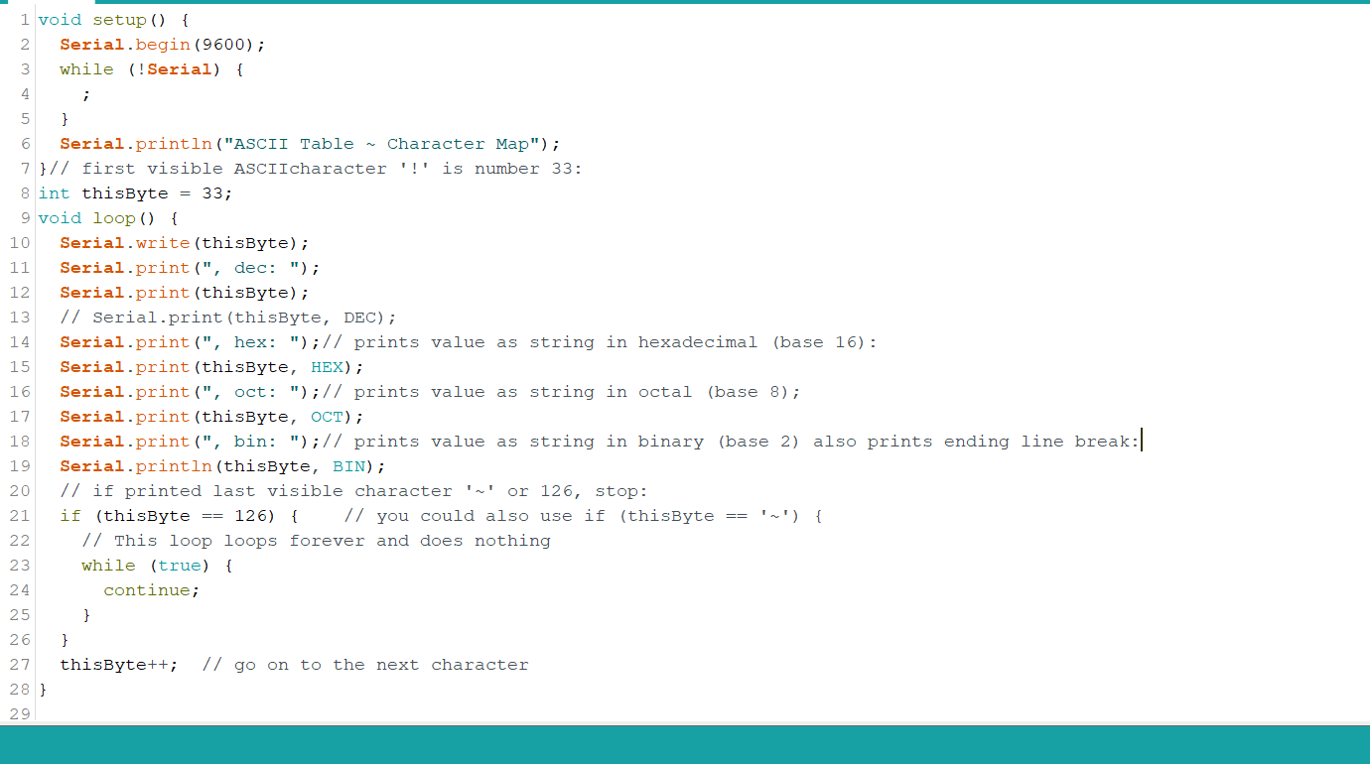

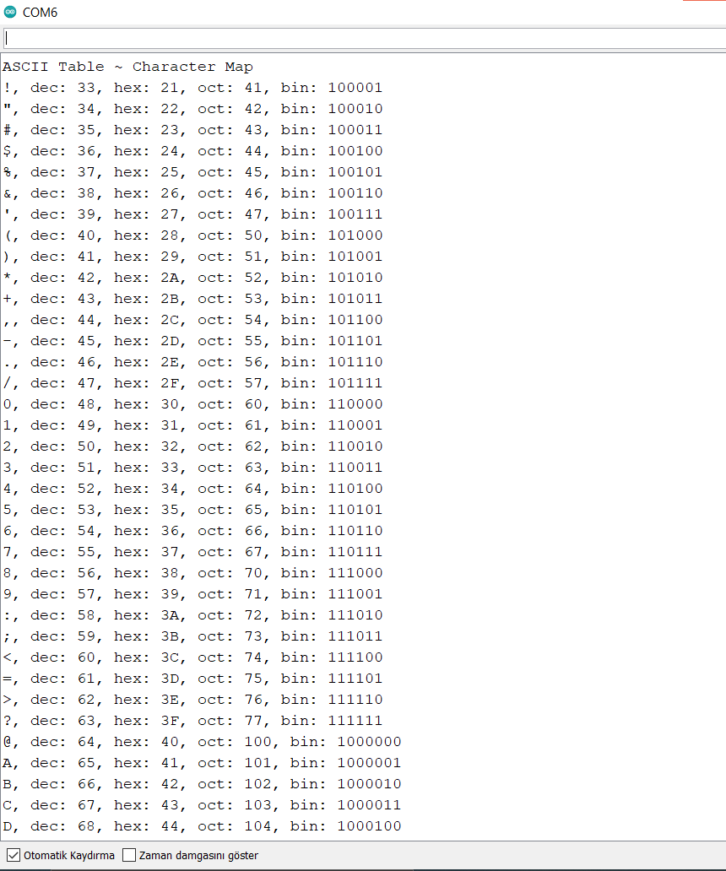

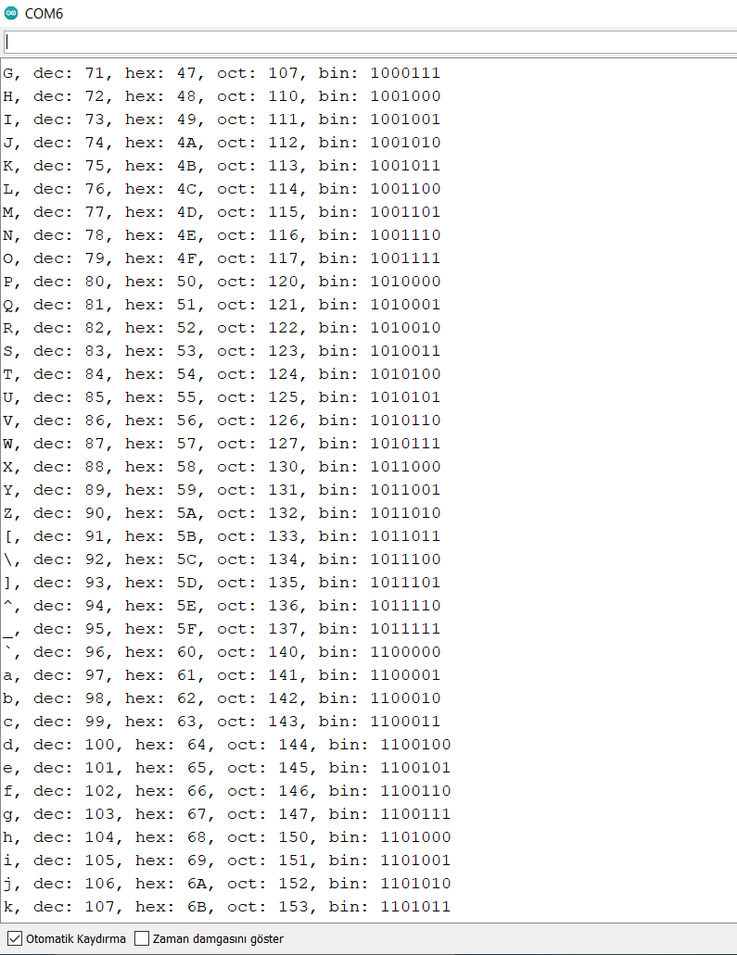

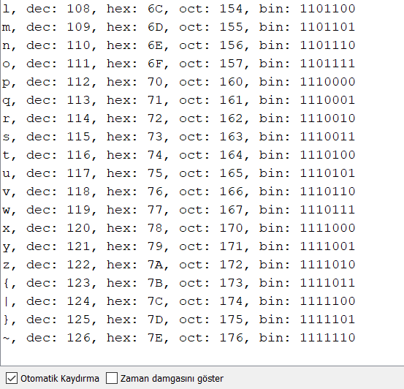

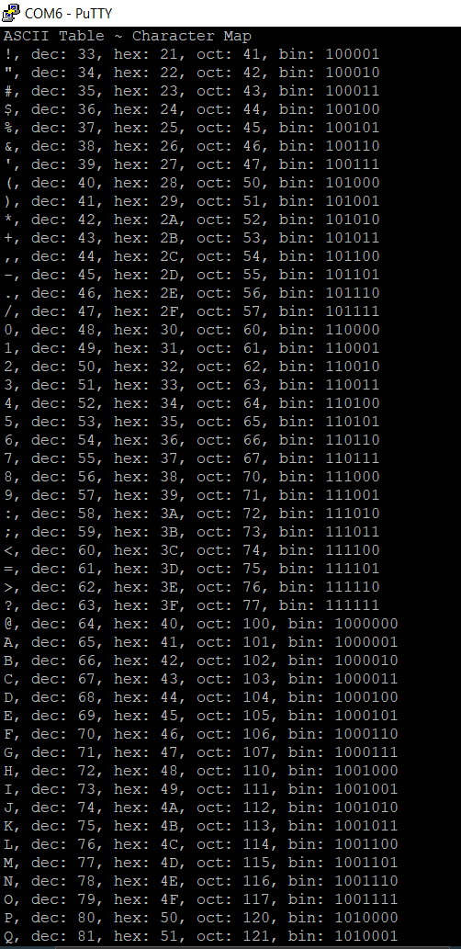

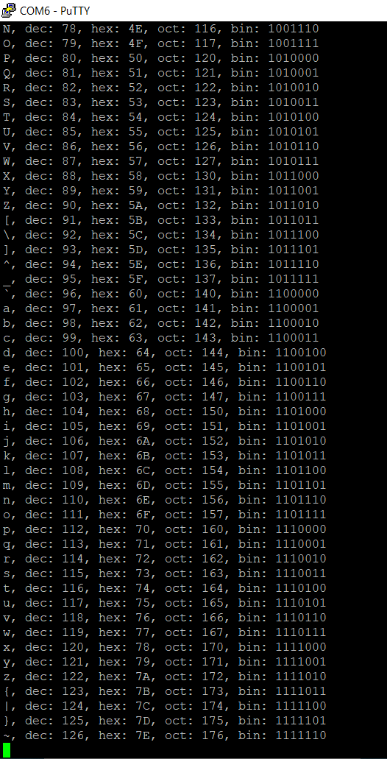

5- Modify The program So that it prints your name and some greetings.

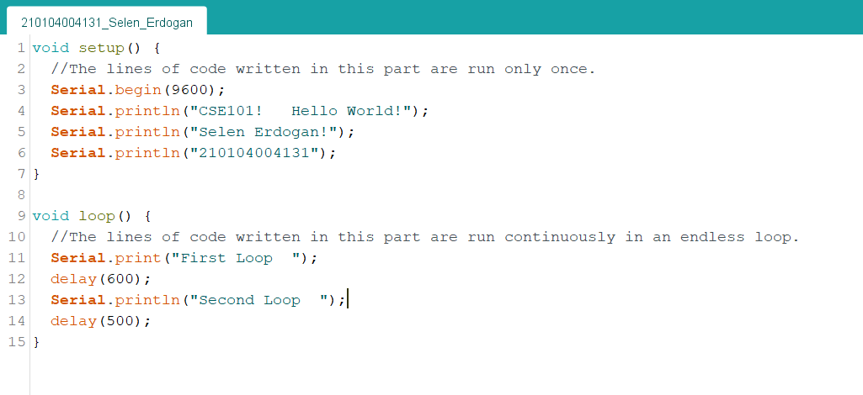

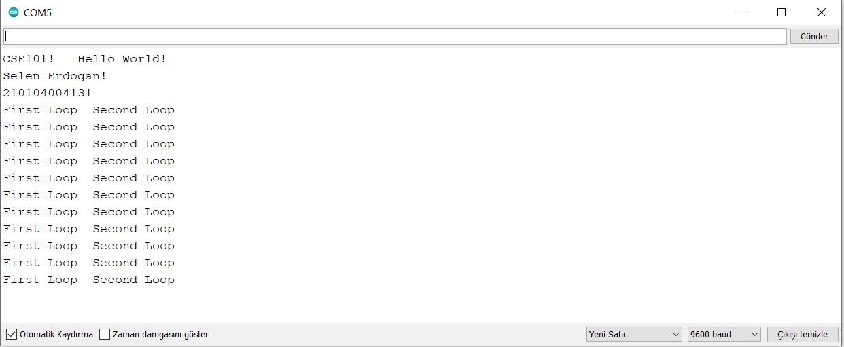

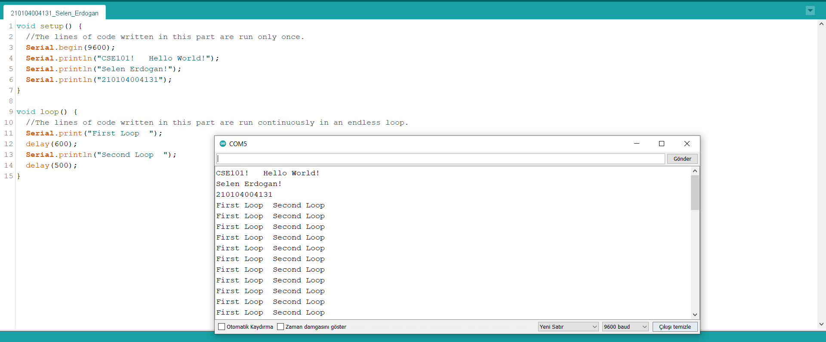

7- Check your program using a serial port application (putty, termite etc) to see if it works without arduino environment, when you reset it

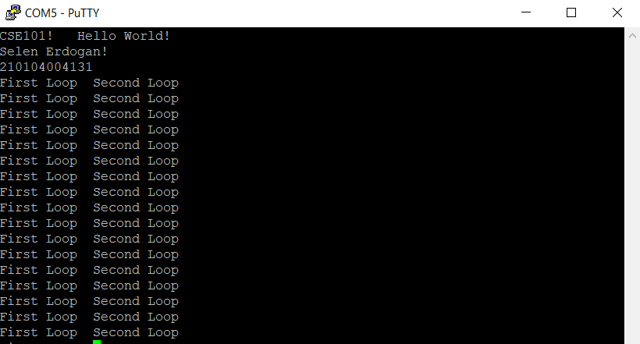

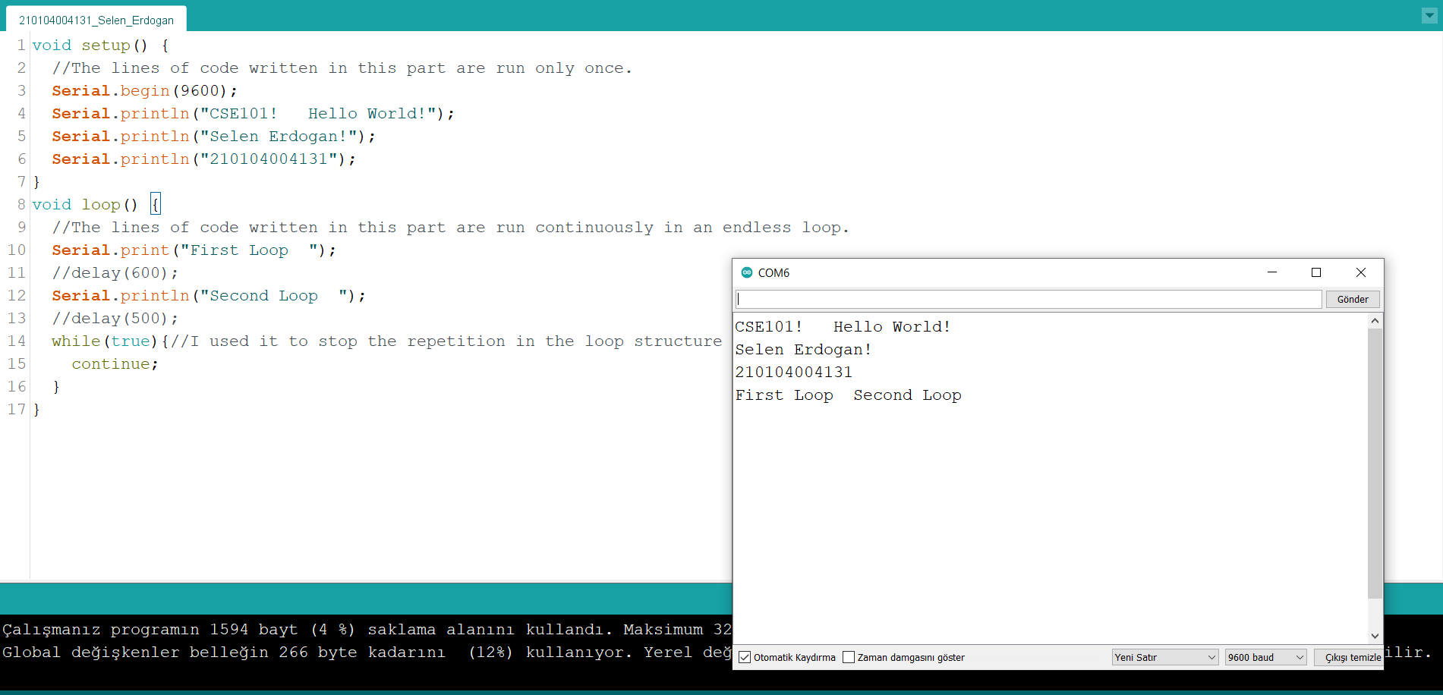

*////I used it to stop the repetition in the loop structure*

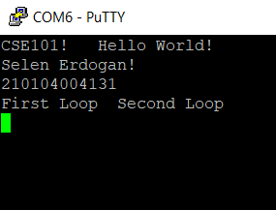

*------------------------------------------------------------------*

*//if .ino folders do not open, i add all codes in here as an extra.*

*1-*

*#define led 13*

*void setup() {*

*pinMode(led, OUTPUT);*

*}*

*//2- Try led blink demo from the demo programs*

*void loop() {*

*digitalWrite(led , HIGH);*

*delay(500);*

*digitalWrite(led , LOW);*

*delay(500);}*

*2-*

*/\**

*Blink*

*\*/*

*// the setup function runs once when you press reset or power the board*

*void setup() {*

*// initialize digital pin LED_BUILTIN as an output.*

*pinMode(LED_BUILTIN, OUTPUT);*

*}*

*// the loop function runs over and over again forever*

*void loop() {*

*digitalWrite(LED_BUILTIN, HIGH); // turn the LED on (HIGH is the voltage level)*

*delay(1000); // wait for a second*

*digitalWrite(LED_BUILTIN, LOW); // turn the LED off by making the voltage LOW*

*delay(1000); // wait for a second*

*}*

*3-*

*void setup() {*

*Serial.begin(9600);*

*while (!Serial) {*

*;*

*}*

*Serial.println("ASCII Table ~ Character Map");*

*}// first visible ASCIIcharacter '!' is number 33:*

*int thisByte = 33;*

*void loop() {*

*Serial.write(thisByte);*

*Serial.print(", dec: ");*

*Serial.print(thisByte);*

*// Serial.print(thisByte, DEC);*

*Serial.print(", hex: ");// prints value as string in hexadecimal (base 16):*

*Serial.print(thisByte, HEX);*

*Serial.print(", oct: ");// prints value as string in octal (base 8);*

*Serial.print(thisByte, OCT);*

*Serial.print(", bin: ");// prints value as string in binary (base 2) also prints ending line break:*

*Serial.println(thisByte, BIN);*

*// if printed last visible character '~' or 126, stop:*

*if (thisByte == 126) { // you could also use if (thisByte == '~') {*

*// This loop loops forever and does nothing*

*while (true) {*

*continue;*

*}*

*}*

*thisByte++; // go on to the next character*

*}*

*4-*

*void setup() {*

*//The lines of code written in this part are run only once.*

*Serial.begin(9600);*

*Serial.println("CSE101! Hello World!");*

*Serial.println("Selen Erdogan!");*

*Serial.println("210104004131");*

*}*

*void loop() {*

*//The lines of code written in this part are run continuously in an endless loop.*

*Serial.print("First Loop ");*

*//delay(600);*

*Serial.println("Second Loop ");*

*//delay(500);*

*while(true){//I used it to stop the repetition in the loop structure*

*continue;*

*}*

*}*

*-------------------------------------------------------------------*